

Structural Design

(Inside View)

**Vertical corrugation**

Design#:

**190559-02**

Customer:

**DeMet's Candy**

Description:

**6ct - Hearts 6.5oz - [1000144 Turtles Vday**

**6.5OZ ][Left hand 1/8"gap]**

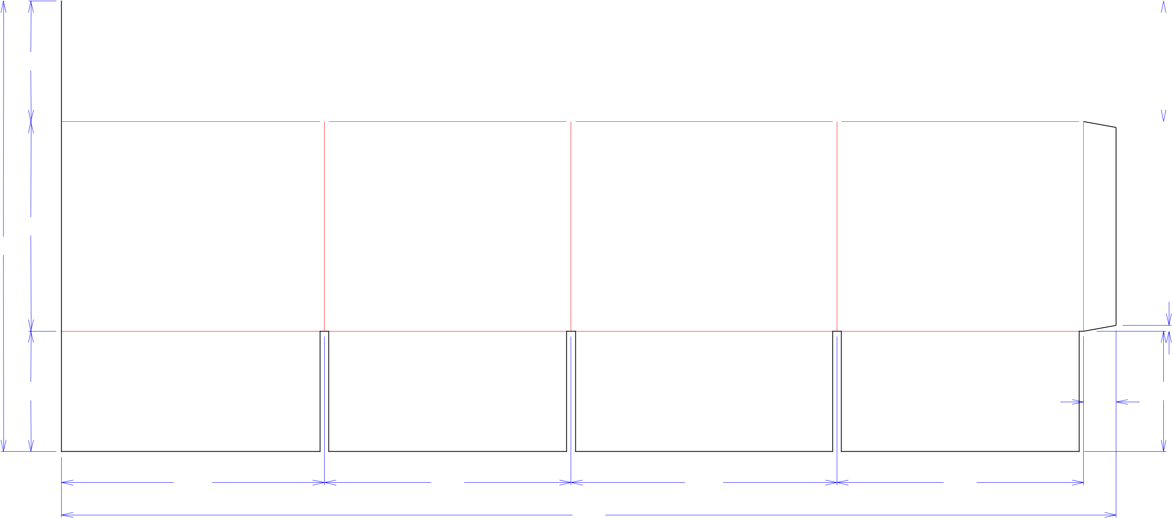

|  |  |  |  |  |  |  |  |  |  |  |  |  |  |  |  |
| --- | --- | --- | --- | --- | --- | --- | --- | --- | --- | --- | --- | --- | --- | --- | --- |
|  |  |  |  |  |  |  |  |  |  |  |  |  |  |  |  |
| 51*/*16 | | |  |  |  |  |  |  |  |  | 51*/*16 | | | | |
|  |  |  |  |  |  |  |  |  |  |  |  |  |  |  |  |

813*/*16

1815*/*16

|  |  |  |  |
| --- | --- | --- | --- |
|  |  |  | 1*/*4 |
| 51*/*16 |  |  | 51*/*16 |
|  |  |  | 13*/*8 |
| 111*/*16 | 103*/*8 | 113*/*16 | 103*/*8 |
|  |  | 443*/*8 |  |

**SINGLE-OUT DRAWING**

Qty/Unit:

Style: **RSC**

Board: **32BK**

Combination: **35HP - 23M - 35HP**

I.D. : **11+1/16 x 10+1/4 x 8+9/16**

**O.D.: 115/16 x 101/2 x 91/16**

Area of Blank - Waste : **5.64 sq. ft.**

Waste on Blank : **3.28%**

Finished Piece Weight: **0.58 lbs./264.01g**

Over-all Blank: **18+15/16 x 44+3/8**

Notes:

**end load RSC**

Revision Info: **[0] 05/13/2019**

Designer: **Alan Groff**

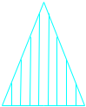

Cut Crease Crease with Matrix Cut Crease Half Knife Cut Tear Tape Perforation



Designright and Copyright of DS Smith Corrugated Packaging Ltd. This technical Specification is subject to Manufacturing tolerances. Drawing dimensions shown are crease to crease. Date printed: 05/13/2019